23.10: The work is the potential energy of the combination.
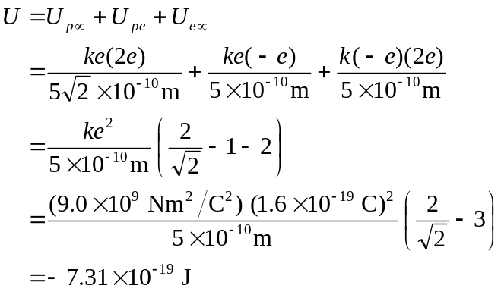
Since U is negative, we want do 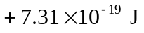 to separate the particles

